8-Part Mini-Webinar Series on Testing & Assessment Methods
This series is for professionals who want to learn more about how to get valid data and develop tests for training and certification. The series is broken down into mini webinars ranging from 45 to 90-minutes. Each webinar includes rules, examples, and tools. You will see good and bad examples and get a digital copy of the workbook and the tool(s). Each webinar costs between $59 to $89. Register at www.HaleCentre.org/events or contact Judy@HaleCenter.org.
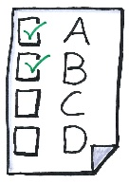
How to Develop Effective Multiple-Choice Questions – 75 minutes; $79. Covers all those pesky details about items and distractors. You get resources your subject matter experts can use over and over. You will see good and bad examples and leave with tips on how to develop valid multiple-choice questions that discriminate those who know from those who don’t
How to Develop Performance-based Tests – 90 minutes; $89. Find out about three different types of performance-based tests and the value and limitations of each. See good and bad examples and get guidelines on how to choose the best type of performance-test for your situation. The tool also includes rules for developing performance-based tests.
How to Develop Checklists - 45 minutes; $59. Learn when and why to use checklists compared to rubrics. The tool and guidelines help you and your subject matter experts develop checklists that capture the key behaviors expected of someone who can do a task to standard. You will see examples of well-designed and poorly designed checklists.

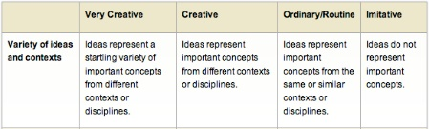
How to Develop Rubrics – 60 minutes; $69. Learn the ins and outs of creating rubrics (scales) ranging from not acceptable to exemplar. Get probing questions to identify the nuances that distinguish the very good from the barely acceptable. See good and bad examples and learn why they work.
How to Create Operational Definitions – 45 minutes; $59. Operational definitions explain what the performance is, why it is important, and how it is done. The output is information you and your subject matter experts can use to design the best testing method. You will see good and bad examples and get a tool designed to help you get valid information.
How to Conduct Observational Interviews – 60 minutes; $69. This is a key skill for anyone who has been charged with finding out how experts do their work and why they make the decisions they do. The tool includes a set of questions you can adapt and a protocol for setting up and conducting the process. You will find out how to avoid common mistakes.
How to Conduct Critical-Incident Interviews – 45 minutes; $59. Ever wonder why some people are just better than other people? This data gathering method is specifically designed to surface the attributes that discriminate those who do well from those who do average. You get guidelines and questions for conducting the interview you can refine for your own situation.
This Photo by Unknown Author is licensed under CC BY-NC
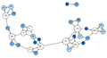
How to Conduct and Interpret a Sociogram – 60 minutes; $69. This technique is used to graphically display group’s communication patterns, specifically who they choose for guidance, information, and recognition. It is used with intact work groups to identify leaders, social cliques, measure group cohesiveness, and find out who is really in charge.
This Photo by Unknown Author is licensed under CC BY-SA
This Photo by Unknown Author is licensed under CC BY-SA
Register at www.HaleCenter.org

