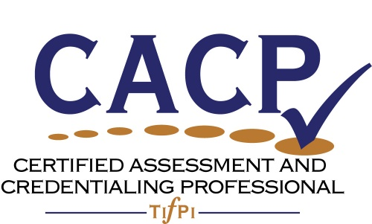

Certified Assessment and Credentialing Professional
Assessment & Maintenance Process:
Part 5
Maintenance & Recertification
Form

Copyright © 2015 by Judith A. Hale and Donna Crisp. These materials or any part thereof may not be reused or reproduced in any form, except by applicants for the purpose of applying for the Certified Assessment and Credentialing Professional designation, known now or hereafter created, without written permission of Hale Associates.

Maintenance and Recertification Requirements

You are required to recommit to the Code of Conduct and achieve 40 points through continuing education and service.

Continuing Education Points: (Minimum of 20 points are required with a maximum of 12 points per event). All of continuing education should relate to some aspect of credentialing and be done over the five-year certification period.
- 1 point for each hour of education or professional event attended live or online.
- 1 point for each white paper, article, or briefing read online or in hard copy.
- 3 points for a half day (3 to 4 hours) educational event attended live or online.
- 6 points for each workshop or conference day (12 points maximum) attended live or online.
- 6 points for reading a book related to credentialing.

Service Points: (Minimum of 5 points with a maximum of 20 points for service). All of service should relate to some aspect of credentialing and be done over the five-year certification period.
- 20 points for writing a book.
- 10 points for contributing a chapter to a book.
- 3 points for serving as a subject matter expert.
- 5 points for each year served on a national or international committee.
- 3 points for each year served on local committees or board.
- 3 points for teaching a workshop over a ½ day in length.
- 5 points for teaching a college level course (semester or quarter).
- 2 points for writing a journal article.
- 3 points for writing an article for a juried journal.
- 1 point for each presentation of 45 to 90 minutes in length at a local, regional, national, or international conference, professional meeting, or equivalent.
Instructions:
Complete the following forms. Insert your first initial and last name at the beginning of the file name [JHale1.CACP 2016 Application for Maintenance]. Return the completed file to Certifications@tifpi.org.

CACP Maintenance & Recertification Application Form

Time Period: MM/DD/YY TO MM/DD/YY:
First Name: Middle Name or Initial: _______________________
Last Name: _______________________________________________________________________
Organization: ____________________
Job Title: ____________________________
Street Address: (Where recertification decal can be sent): _________________________________
City/State/County/ZIP or Postal Code: ___________________________________
Phone: _______________________________ Fax __________________________________________
Email ___________________________

CACP Code of Conduct

Statement of Expectations: The Code of Conduct and the CACP Standards are intended to promote ethical practices in the creation and maintenance of credentials. By signing the Application Agreement, you indicate that you agree to abide by the following Code of Conduct:

- Add Value
I agree to conduct myself and my work in ways that add value to certificants, the credentialing agency, stakeholders, professional community, and society.

- Validated Practice
I agree to follow best practices in credentialing in keeping with the Standards of the CACP.

- Collaborate
I agree to work collaboratively with stakeholders, certificants, and colleagues functioning as a trustworthy strategic partner.

- Continuous Improvement
I agree to engage in activities designed to continuously improve my proficiency in the practice of credentialing.

- Integrity
I agree to be honest and forthright in my representations to colleagues, stakeholders, and others with whom I may come in contact while managing or supporting credentialing programs.

- Confidentiality
I agree to maintain the confidentiality of applicants’ data, individual personnel data, and other information that should not be shared publicly.

- Conflict of Interest
I agree to avoid any actual or semblance of conflict of interest from which I will or may derive benefits not equitably offered others.

_____________________________ _____________________________ __________
Printed Name Signature Date

Continuing Education (Minimum of 20 points is required):
Insert a half-half page narrative containing a description of the event or book that includes: the sponsor, author, speaker or facilitator; timespan or date; with a reflection on the insights gained from this experience.
Event/Book Name | Sponsor/Author/Facilitator | Points | Time Span
Description and insights gained

Copy the above table for each additional event or book.

Service (Minimum of 5 points and a maximum of 20 points):
Insert a half-page explanation of the type of service rendered with a reflection on the insights gained from this experience, and the timeframe during which the service was rendered.
Type of Service | Sponsor | Points | Time Span
Description and insights gained

Copy the above table for each additional service rendered.

