Middle and High School
Six Guiding Principles©
Digital Badge/Certificate Guide

Developed by Hale Associates
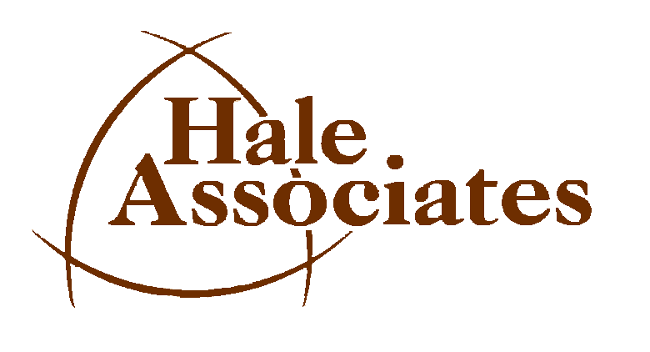
Integrity, Innovative, Intelligence
Developing Innovative Solutions for More Than 40 Years

RISE ABOVE® Back-to-School Campaign
https://cafriseabove.org/school

Middle and High School Six Guiding Principles© Digital Badges/Certificate Guide

This guide includes:
- Instructions
- Suggested timeframe for each principle
- Rubrics for each of the six principles
- Recommendations for scoring students’ work
- A printable certificate (See Six Guiding Principles PP in “Six Guiding Principles Digital Badge/Certificate Guides” folder in Teacher Toolkit)
- Downloadable digital badges (included on page 6 of this guide) for each principle

Instructions
- At the beginning of the school year:
a. Explain what the students must do to earn a digital badge or certificate for each principle
b. Explain that the Red Tail Spirit Award will be awarded to students earning all six certificates throughout the year (provided in “Six Guiding Principles Digital Badge/Certificate Guides” folder in Teacher Toolkit).
- Explain the rubric:
  - Modify and add factors to any of the rubrics to make it more relevant to your class.
  - Adjust the scoring if you add or eliminate a factor.
- Explain when and how students will work on the principles throughout the school year. You may adjust the calendar to better meet your students’ needs.
- Model the six principles in your own behavior.
  - Create a plan for the class and each student.
  - Tell students of your high expectations of them.
  - Demonstrate belief in yourself.
  - Talk about how to use your brain when faced with goals and adversity.
  - Never quit.
  - Expect the class to be successful.
Suggested timeframe for focusing on each principle
Principle | J | A | S | O | N | D | J | F | M | A |  | M
Be Ready to Go
Aim High
Believe in Yourself
Use your Brain
Never Quit
Expect to Win

The Rubric and Scoring Suggestions

The rubric and scoring suggestions are on pages 3-5.

Digital Badges/Certificates Rubric

Student’s name___________________________ Teacher’s Name_______________________________ Grade___________

Principle | Rubric |  |  | Score
Be Ready to Go | 4 pts | 2 pts | 0 pts
Time 6 to 8 weeks  Maximum points are 32. To earn this badge the student must have  - No 0s and at  - Least 24 points | Has goal(s) & plan with steps | Has a goal(s), but missing steps | Has a no goal(s) or no steps
 | Comes to class every day with all the materials needed for classwork | Comes to class every day with most of the materials needed for classwork. | Does not come to class with any of the materials needed for classwork
 | All homework is completed | Some homework is completed | No homework is completed
 | Can always explain what is needed to accomplish a task | Can sometimes explain what is needed to accomplish a task | Cannot explain what is needed to accomplish a task
 | Shares ideas to facilitate the success of a group or team | Occasionally shares ideas to facilitate the success of a group or team | Does not share ideas to facilitate the success of a group or team.
 | Takes opportunities to help others | Sometimes acts on opportunities to help others | Does not take opportunities to help others
 | Comes to class every day with all the materials needed for classwork | Comes to class every day with most of the materials needed for classwork. | Does not come to class with any of the materials needed for classwork
 | All homework is completed | Some homework is completed | No homework is completed
Total Points

Aim High | 4 points | 2 points | 0 points
Time 6 to 8 weeks  Maximum points are 16. To earn this badge, student must have  - No 0s and at  - Least 12 points | Goal(s) is aspirational | Goal is moderately aspirational | Goal(s) lack aspiration
 | Work reflects high expectations of self | Work reflects moderate expectations of self | Work does not reflect high expectations of self
 | Constantly strives to reflect on and improve performance | Occasionally strives to reflect on and improve performance | Never strives to reflect on and improve performance
 | Takes responsible risks to improve self | Occasionally takes responsible risks to improve self | Never takes responsible risks to improve self
Total Points

Principle | Rubric |  |  | Score
Believe in Yourself | 4 points | 2 points | 0 points
Time 6 to 8 weeks  Maximum points are 12. To earn this badge student must have:  - No 0s and at  - Least 9 points | Self-rates confidence as high | Self-rates confidence as neutral | Self-rates confidence as low
 | Does not question own ability in doing work | Sometimes questions own ability in doing work | Always questions own ability in doing work
 | Always remains open to new or complex learning | Sometimes tries to learn new or complex things | Avoids or rejects new or complex learning
Total Points

Use Your Brain | 4 points | 2 points | 0 points
Time 6 to 8 weeks  Maximum points are 24. To earn this badge student must have:  - No 0s and at  - Least 18 points | Can explain rationale for work or behavior | Occasionally explains rationale | Assumes and cannot explain rationale for work or behavior
 | Can identify barriers to learning | Occasionally can explain barriers | Cannot identify barriers to learning
 | Possesses and uses basic skills to accomplish tasks | Possesses and sometimes uses basic skills to accomplish tasks | Possesses but does not use basic skills to accomplish tasks
 | Always attempts to solve problems | Sometimes attempts to solve problems | Never attempts to solve problems
 | Applies past knowledge to new situations | Sometimes applies past knowledge to new situations | Does not apply past knowledge to new situations
 | Always considers alternatives and consequences before acting | Sometimes considers alternatives and consequences before acting | Acts before thinking
Total Points

Never Quit | 4 points | 2 points | 0 points
Time 6 to 8 weeks  Maximum points are 16. To earn this badge student must have:  - No 0s and at  - Least 12 points | Meets timelines for completing tasks | Is behind on steps to complete tasks | Is way behind on steps to complete tasks
 | Always chooses to employ a pattern of productive behaviors | Sometimes chooses to employ a pattern of productive behaviors | Chooses to employ less productive behaviors
 | Perseveres at all tasks to completion | Perseveres at some tasks to completion | Does not persevere at tasks until completion
 | Always analyzes problems and has a repertoire of alternative strategies to solve them | Sometimes analyzes problems and has a limited repertoire of alternative strategies | Never analyzes problems and does not try to solve them
Total Points

Principle | Rubric |  |  | Score
Expect to Win | 4 points | 2 points | 0 points
Time 6 to 8 weeks  Maximum points are 16. To earn this badge student must have:  - No 0s and at  - Least 12 points | Can explain what accomplishment will feel like | Sometimes explains what accomplishment will feel like | “Not my fault” is a common response
 | Demonstrates a desire for accuracy to produce exemplary results in assigned or voluntary tasks | Sometimes demonstrates a desire for accuracy to produce exemplary results in assigned or voluntary tasks | Never demonstrates a desire to produce exemplary results in assigned tasks and rarely volunteers for tasks
 | Always seeks opportunities to learn and prepare to facilitate successful accomplishment of goals | Sometimes seeks opportunities to learn and prepare to facilitate successful accomplishment of goals | Does not seek opportunities to learn and prepare to facilitate successful completion of goals
 | Never questions personal ability or preparedness to succeed | Sometimes questions personal ability or preparedness to succeed | Always questions personal ability or preparedness to succeed
Total Points

TOTAL CERTIFICATES EARNED FOR YEAR

NOTE: Students earning all Six Guiding Principles certificates throughout the year receive the Red Tail Spirit Award certificate that is provided in the “Six Guiding Principles Digital Badge/Certificate Guides” folder in the Teacher Toolkit.
Digital Badges
