CSIS Application Payment Process

- Go to Events

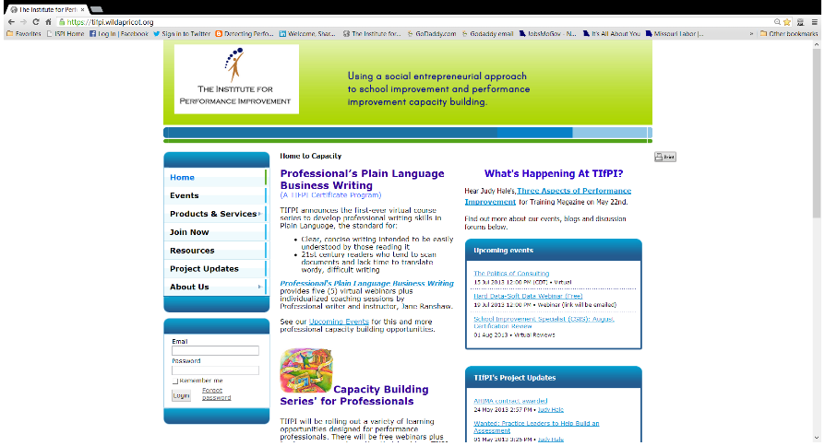

- Scroll to find, School Improvement Specialist (CSIS): {month} Certification Review.
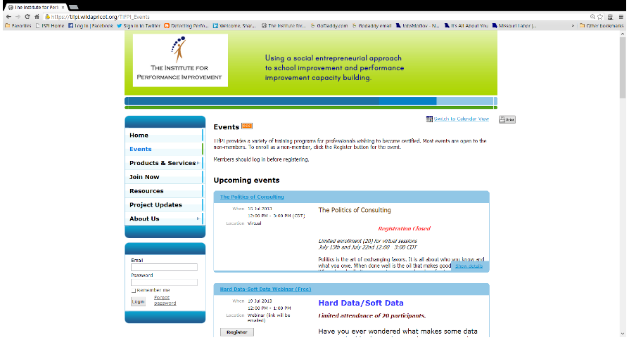
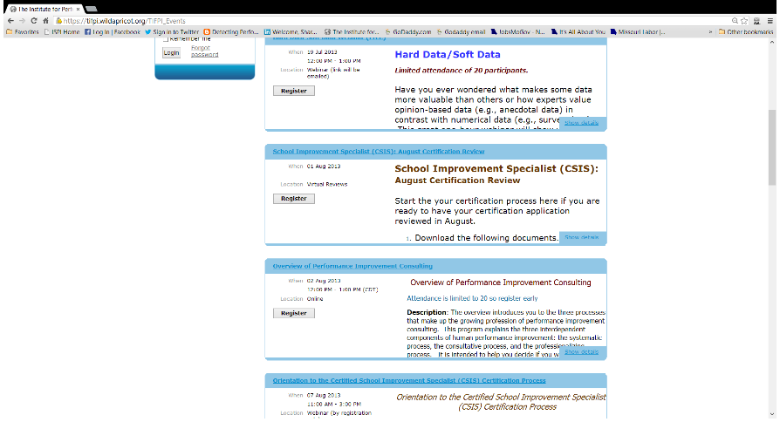

- Click on show details to expand the description and register.
- Click links to download application form, handbook and standards.
- Fill in your preferred email address and the Capcha code.
- 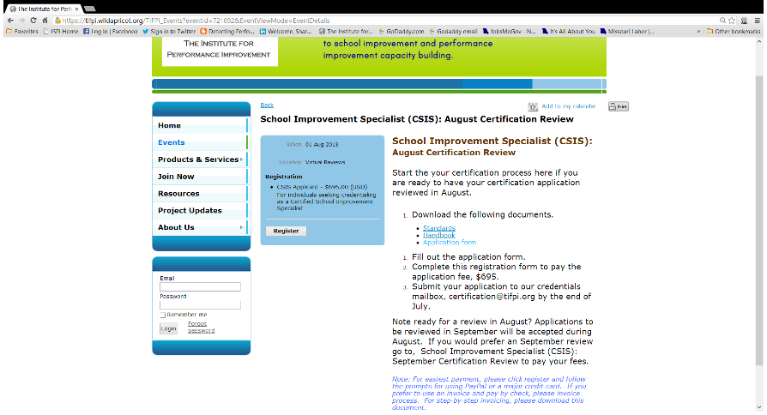
- Click Register button to begin registration process for either online payment or invoicing with mailed-in payment.
- Fill in your preferred email address and the Capcha code.
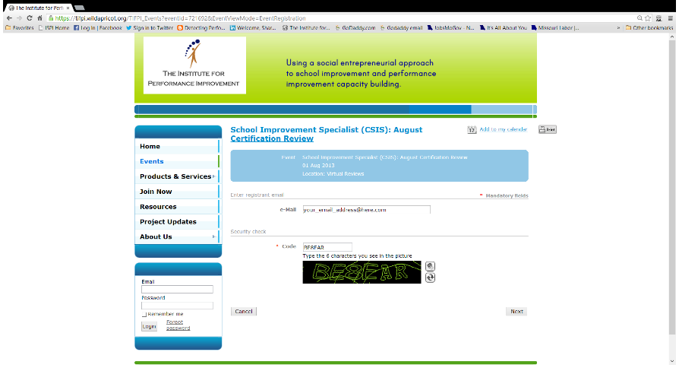

- Click Next to continue.
- Click Next, after completing the demographics form (we need to know how to reach you).
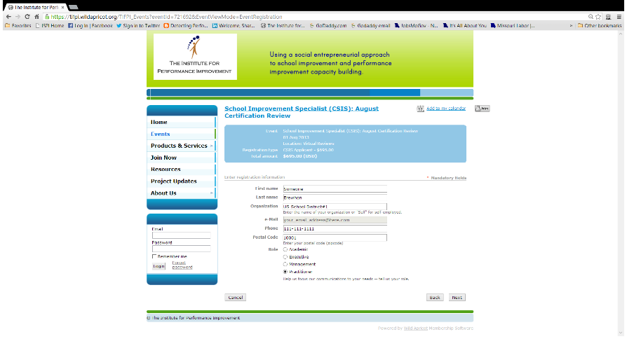
- Click Confirm and Proceed, after verifying your demographics.

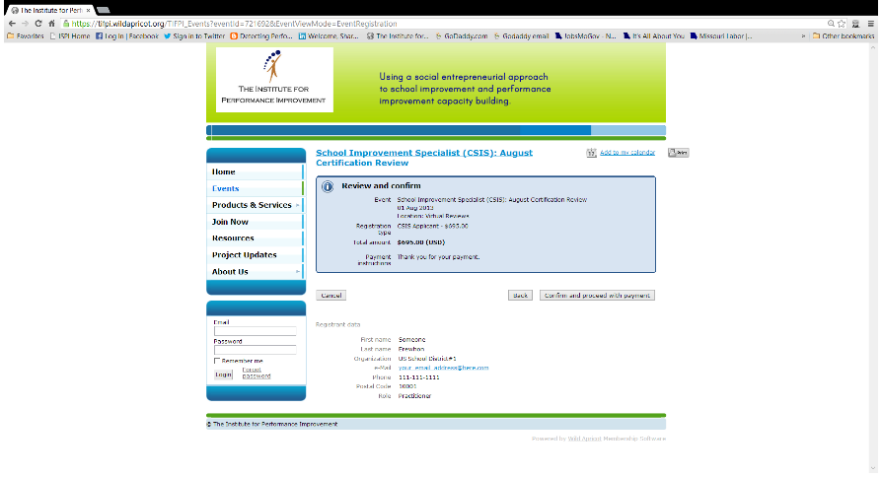
Optional: If you prefer the invoice and pay-by-check method, use the print button to print out this page as the invoice. Then mail in your payment.
When we receive your check and copy of invoice, we will complete the registration process by hand.

- Click Pay Online button to proceed to PayPal’s financial engine where you may pay using PayPal or a major credit card.

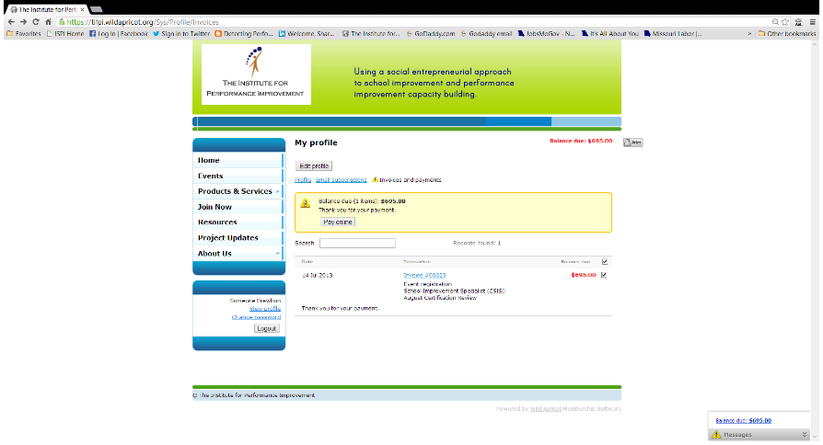

On the PayPal screen, choose your payment method – (a) using your PayPal account, or (b) using a credit card as a “guest”.
  - When using your PayPal Account, click Have a PayPal Account? and follow prompts.
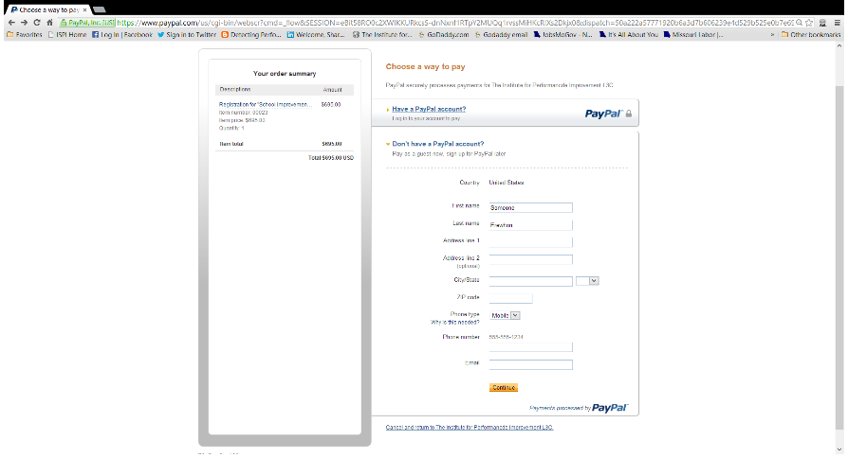

  - Click Continue, after correctly filling in the online form as a “guest”.
(Requires completion of all data.)
    - Fill in credit card information and follow prompts.
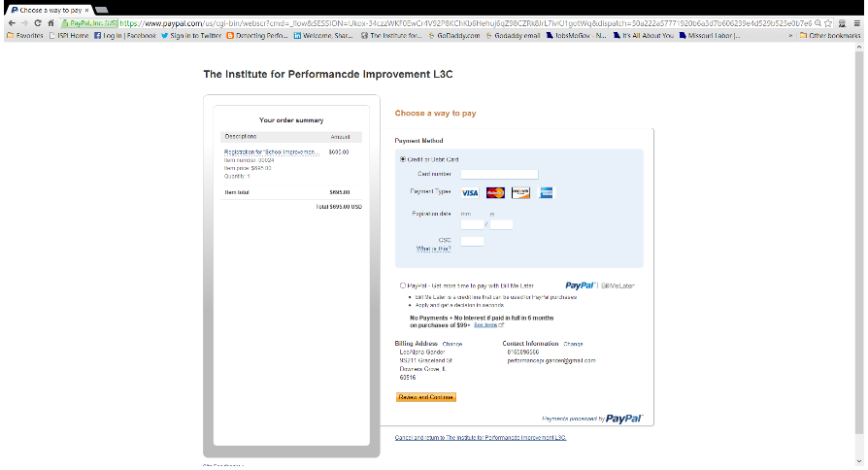
- You will receive confirmation from admin@tifpi.com and from PayPal.

